Installed Terraform and AWS CLI

Edited path of Environmental Variables

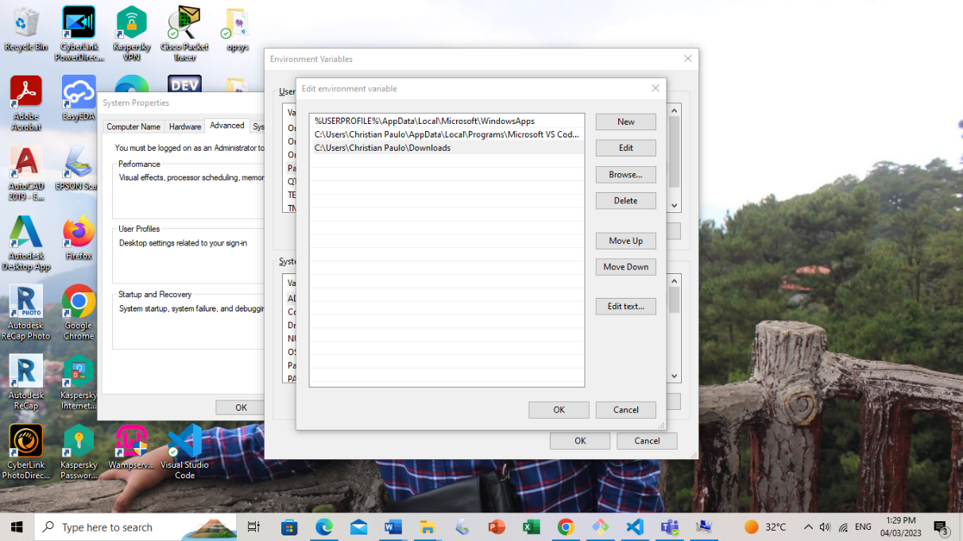

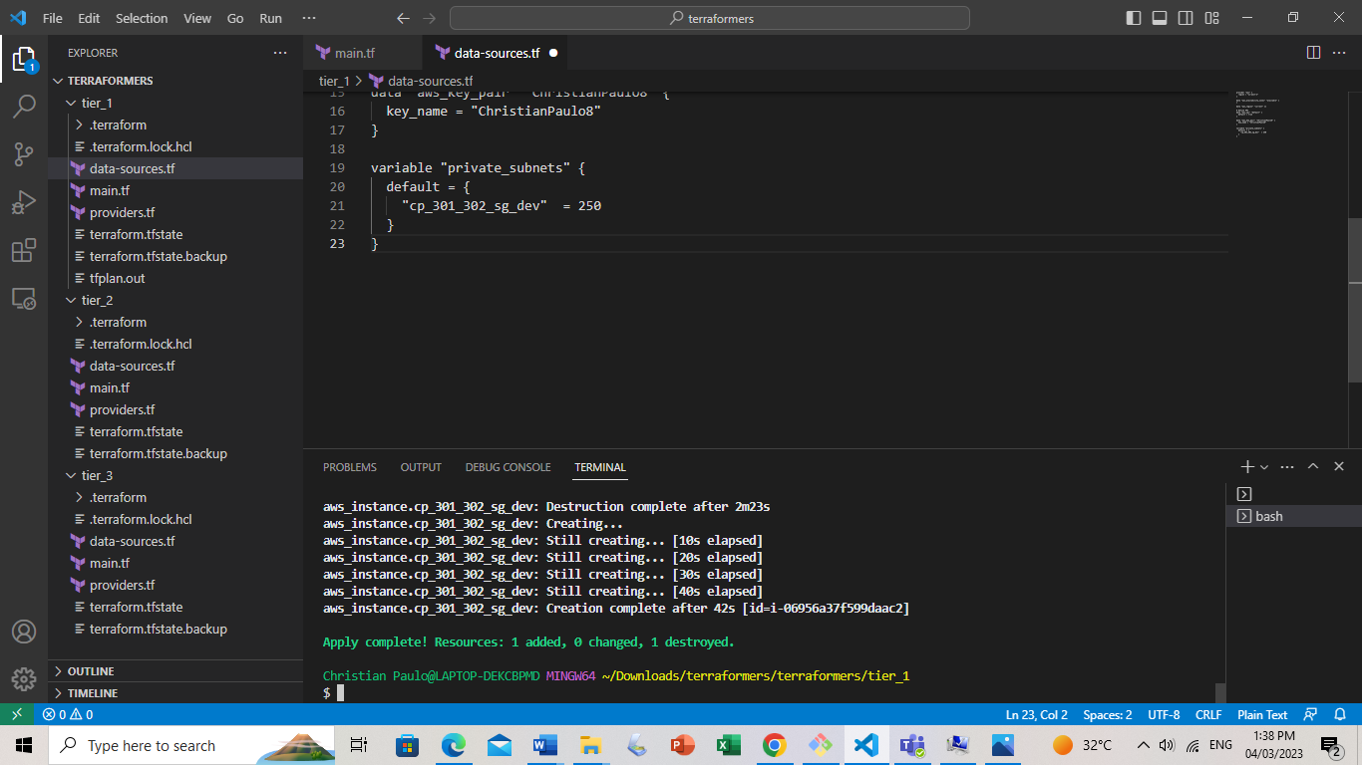This is Tier 1. Changed the key name and changed private subnets to avoid conflicts. Typing “terraform apply” to install on instance.

Repeat the process on Tier 2. Change key name and private subnets to avoid conflicts between tiers and then type “terraform apply”.

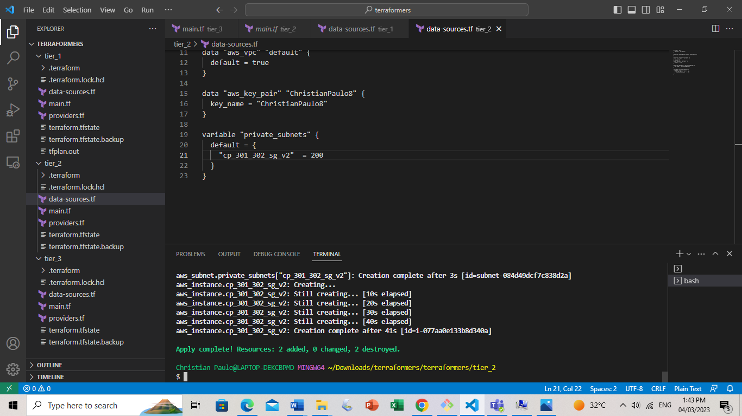

Repeat the process in Tier 3 from previous 2 tiers and then type “terraform apply”.

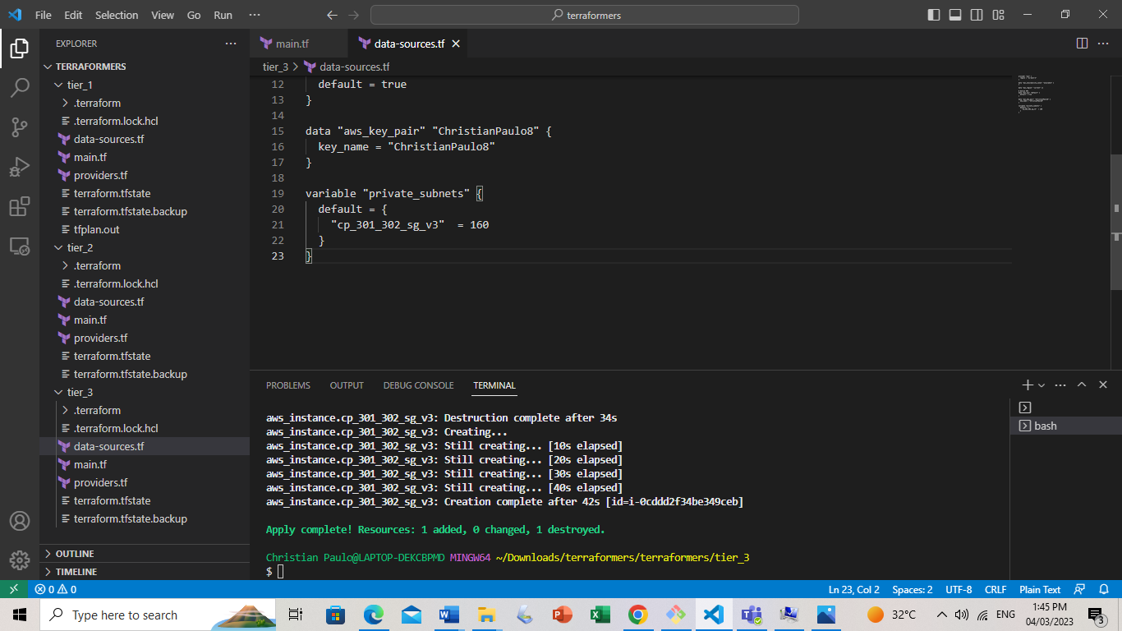

Open EC2 and Refresh to Finalize. Make sure all 3 Tiers are shown.

